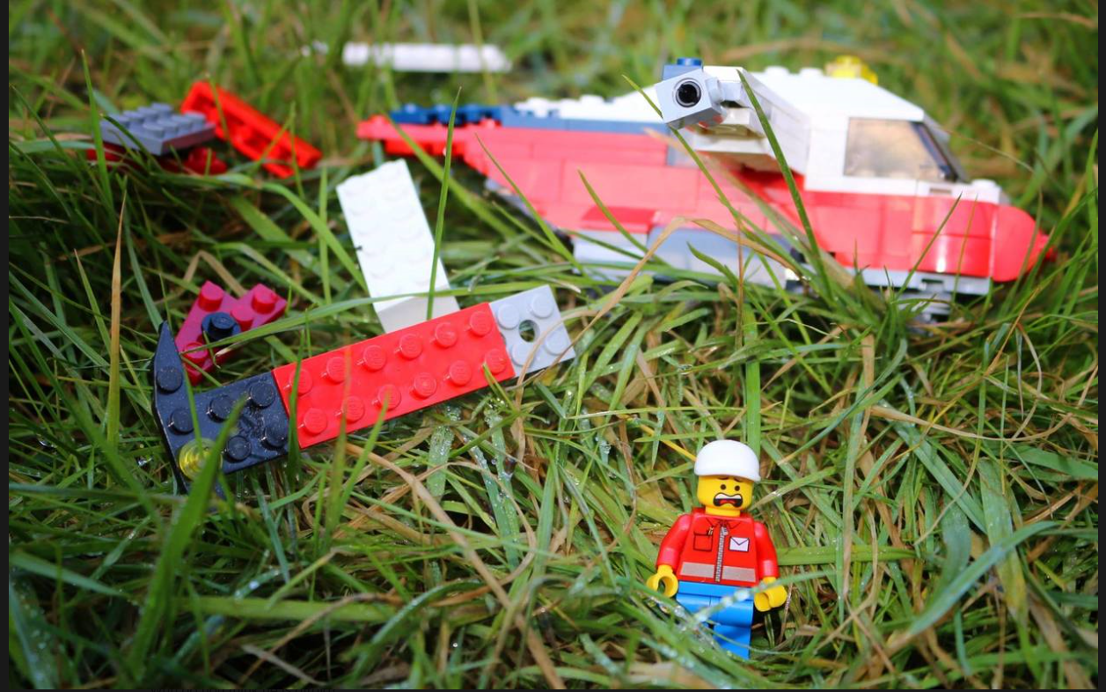
Year 1
Use one of the sentence starters below and the word bank to help you write an interesting story that matches this picture.

There was a flash of light, a loud explosion and
suddenly……………….
Everywhere I look I saw ……………………….
Noisy celebration steering
Amazement accelerate engine
Awe bumpy forest
Exploding crashing cornering

